**Experiment 1**

**Name : Shaikh Mubashira Tufel Ahmed**

**RollNo : 612055 Branch : T.E. I.T**

1. **What is DevOps ?**

🡺DevOps is the combination of cultural philosophies, practices, and tools that increases an organization’s ability to deliver applications and services at high velocity: evolving and improving products at a faster pace than organizations using traditional software development and infrastructure management processes. This speed enables organizations to better serve their customers and compete more effectively in the market.

1. **What is AWS EC2?Why EC2.**

🡺Amazon Elastic Compute Cloud (EC2) is a part of Amazon.com's cloud-computing platform, Amazon Web Services, that allows users to rent virtual computers on which to run their own computer applications.

Amazon EC2 provides the following features:

● Virtual computing environments, known as instances

● Preconfigured templates for your instances, known as Amazon Machine Images (AMIs), that package the bits you need for your server (including the operating system and additional software)

● Various configurations of CPU, memory, storage, and networking capacity for your instances, known as instance types

● Secure login information for your instances using key pairs (AWS stores the public key, and you store the private key in a secure place)

● Storage volumes for temporary data that's deleted when you stop, hibernate, or terminate your instance, known as instance store volumes

● Persistent storage volumes for your data using Amazon Elastic Block Store (Amazon EBS), known as Amazon EBS volumes

● Multiple physical locations for your resources, such as instances and Amazon EBS volumes, known as Regions and Availability Zones

● A firewall that enables you to specify the protocols, ports, and source IP ranges that can reach your instances using security groups

● Static IPv4 addresses for dynamic cloud computing, known as Elastic IP addresses

● Metadata, known as tags, that you can create and assign to your Amazon EC2 resources

● Virtual networks you can create that are logically isolated from the rest of the AWS Cloud, and that you can optionally connect to your own network, known as virtual private clouds (VPCs)

1. **Launch two instances of AWS EC2, one in windows and another in ubuntu . Get connected to instances using RDP and MobaXterm client software. Explain each step of EC2 creation and launching with the help of screenshots. Open google.com from both the instances ,search your own name .**

**(A) For Windows:**

**Step 1: Management Console Dashboard**

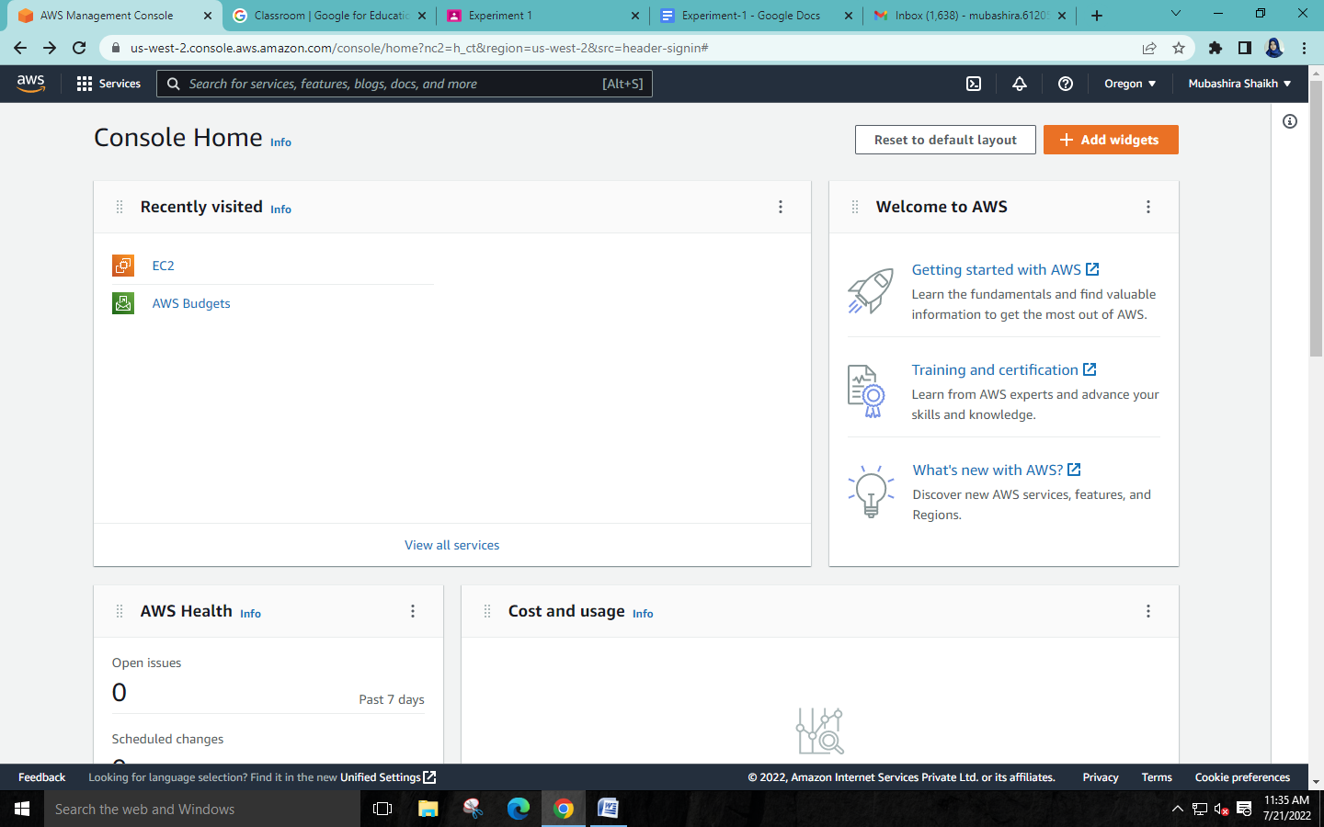

**Step 2: Click on view all services and then click on EC2**

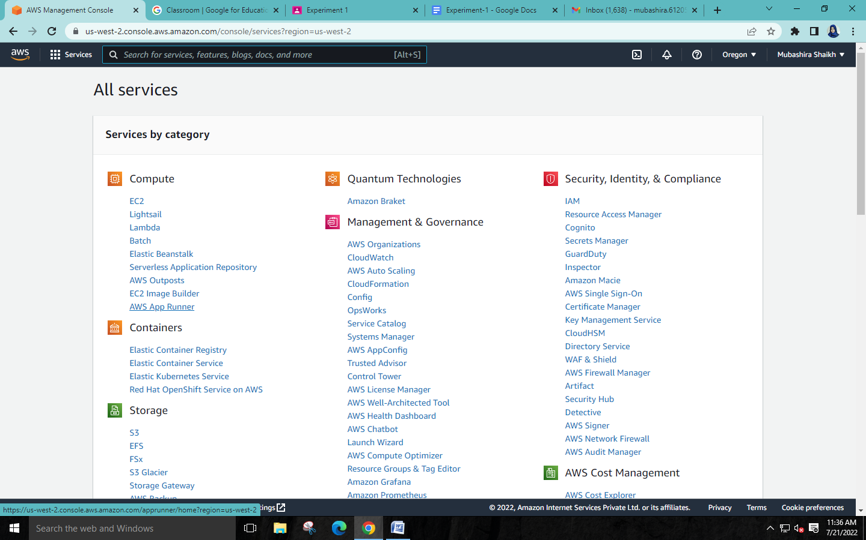

**Step 3: Launch instance**

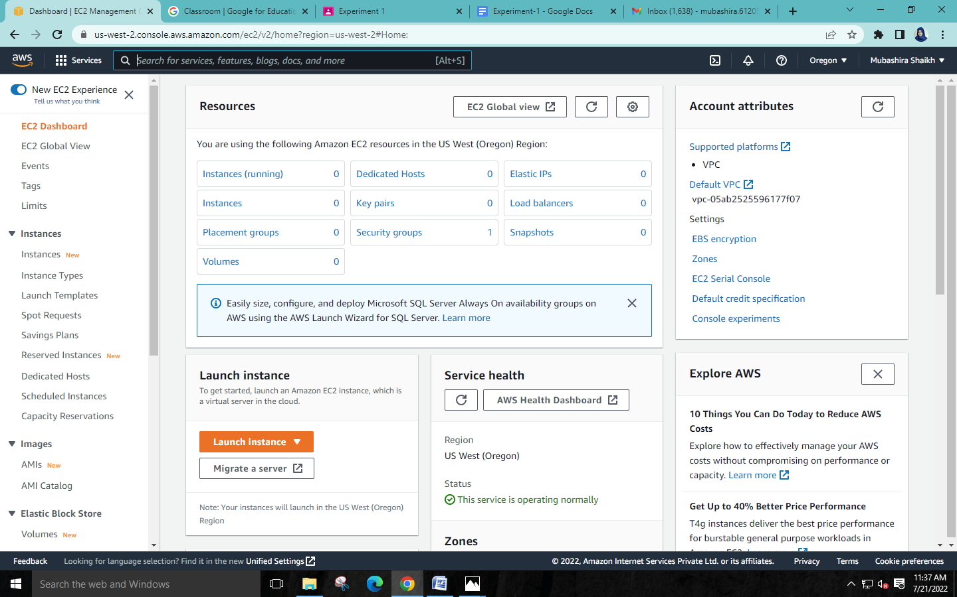

**Step 4: Select Windows**

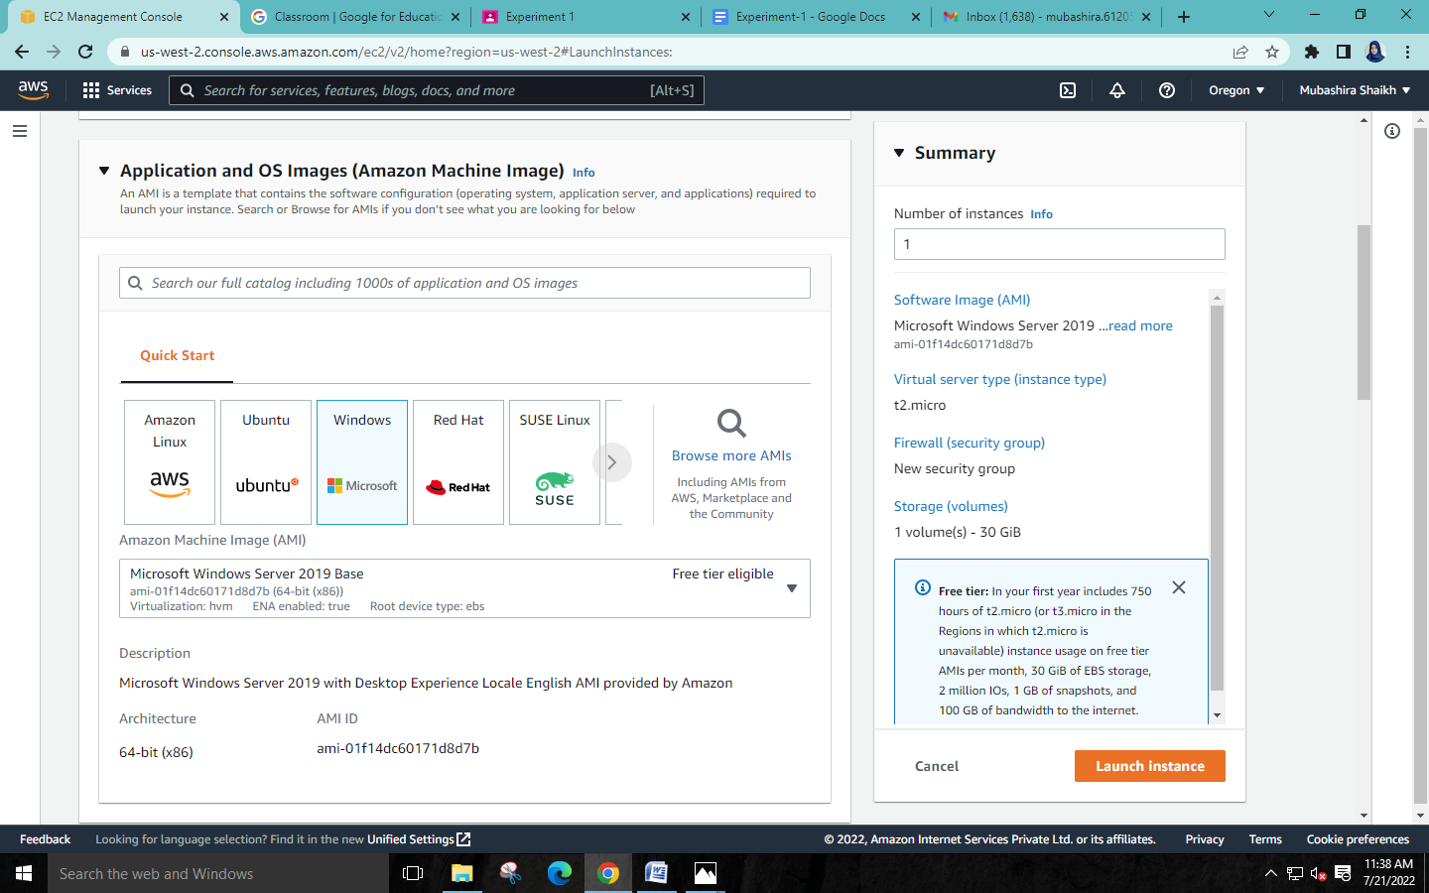

**Step 5: Select instance with free tier**

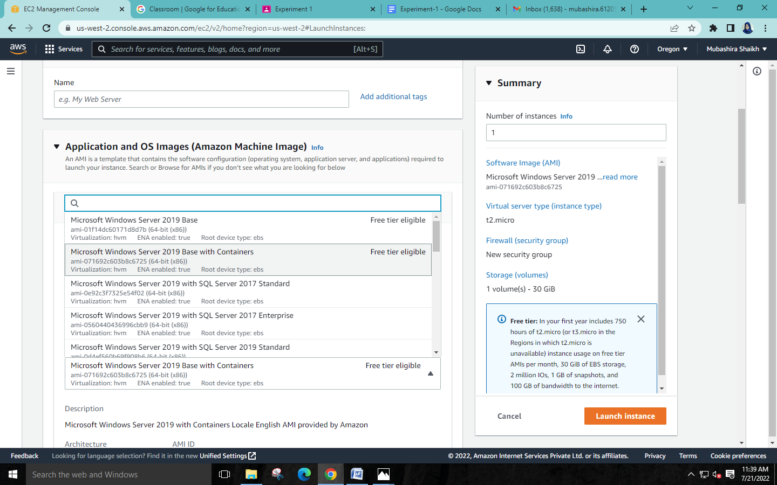

**Step 6: Login key**

**Create a login key which is required for logging in to the instance**

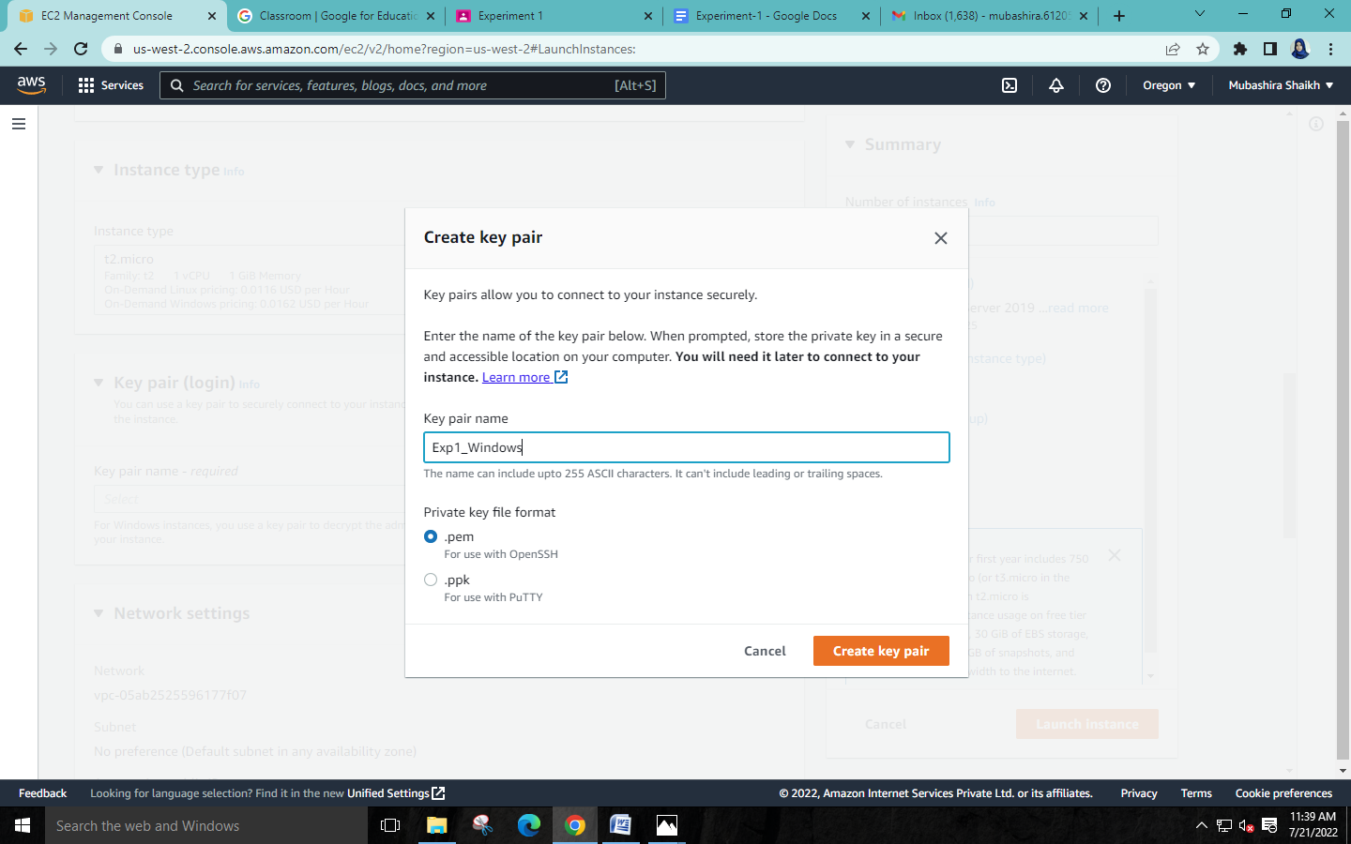

**Step 7: Security: Anywhere should be selected so we can access the instance from any ip address**

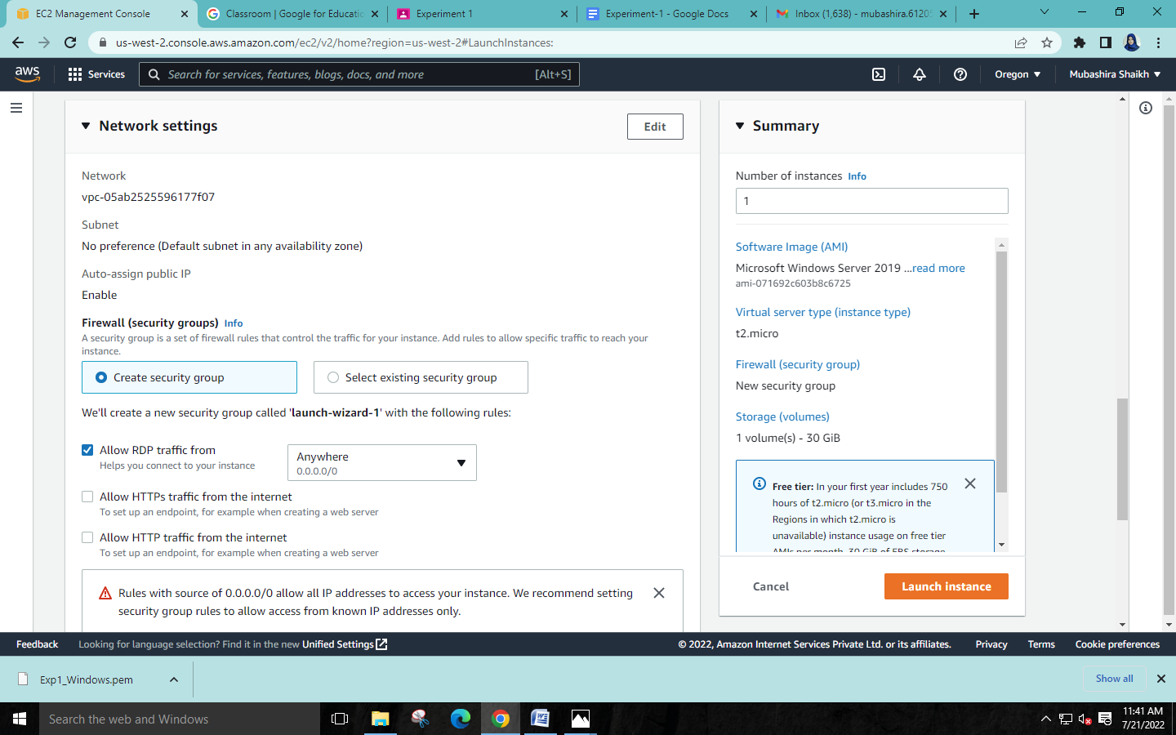

**Step 8: Launch instance**



**\* Success msg will be shown after succucessfull creation of instance**

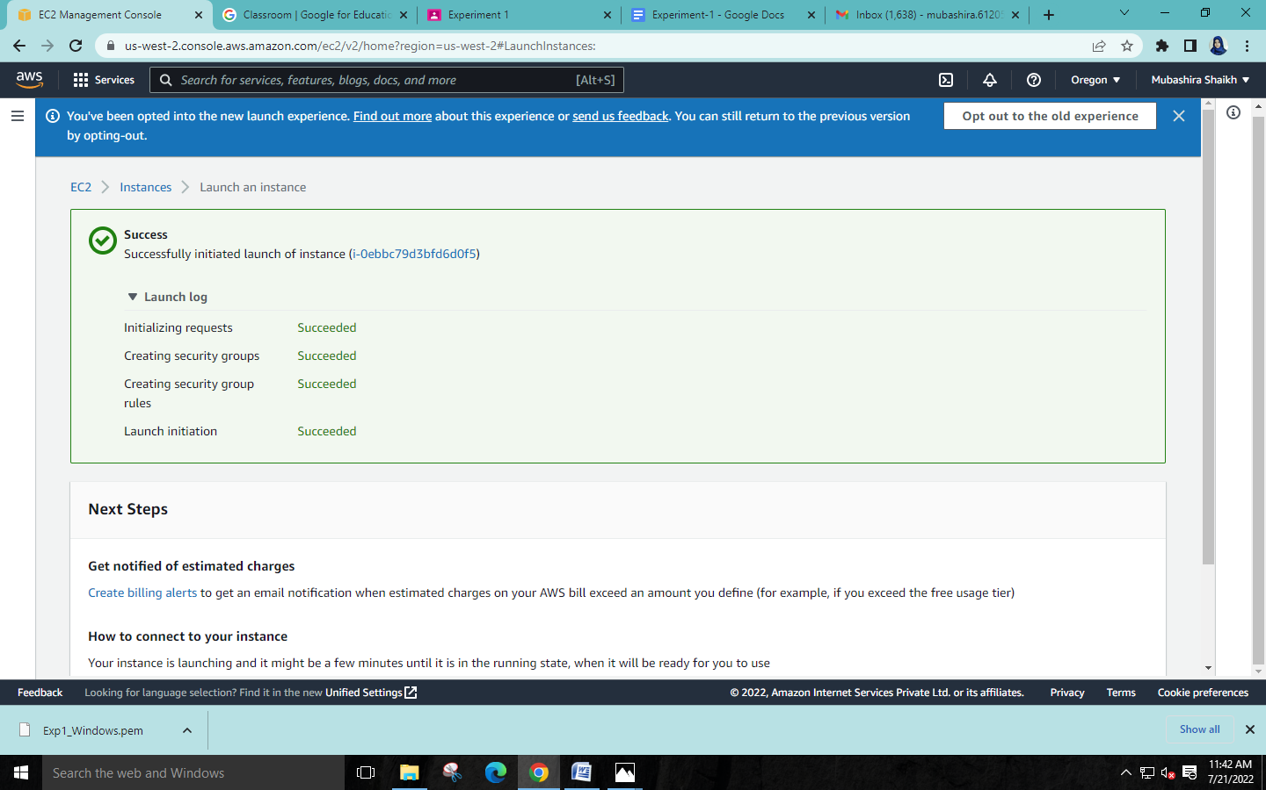

**Step 9: RDP connection :**

**For connection we have to download the desktop file as shown in the image below**

**And have to decrypt the password which we downloaded by login key in the form of .pem file After that simply run the desktop file . the instance will start running.**

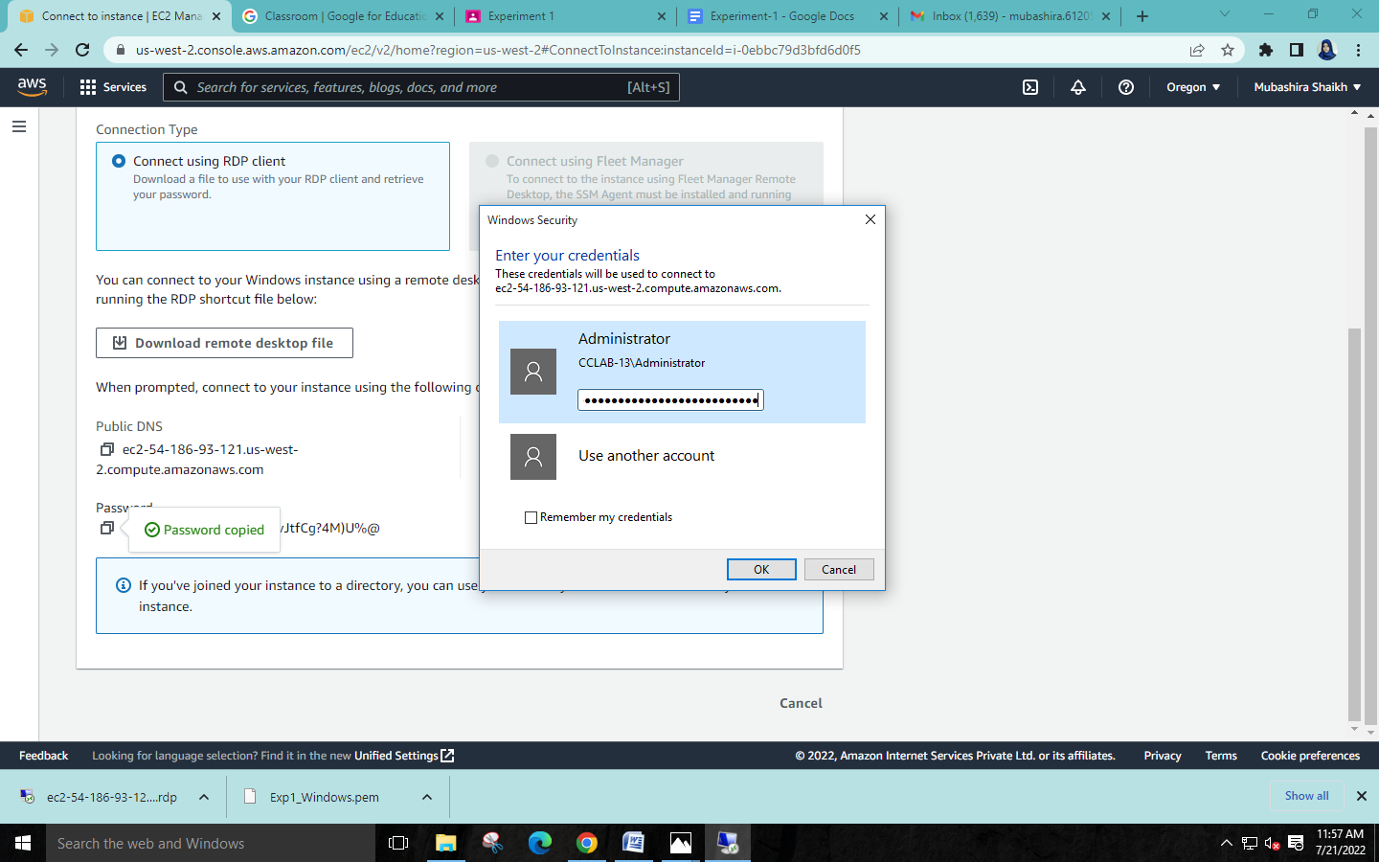

**Step 10: Opening google.com to search name**

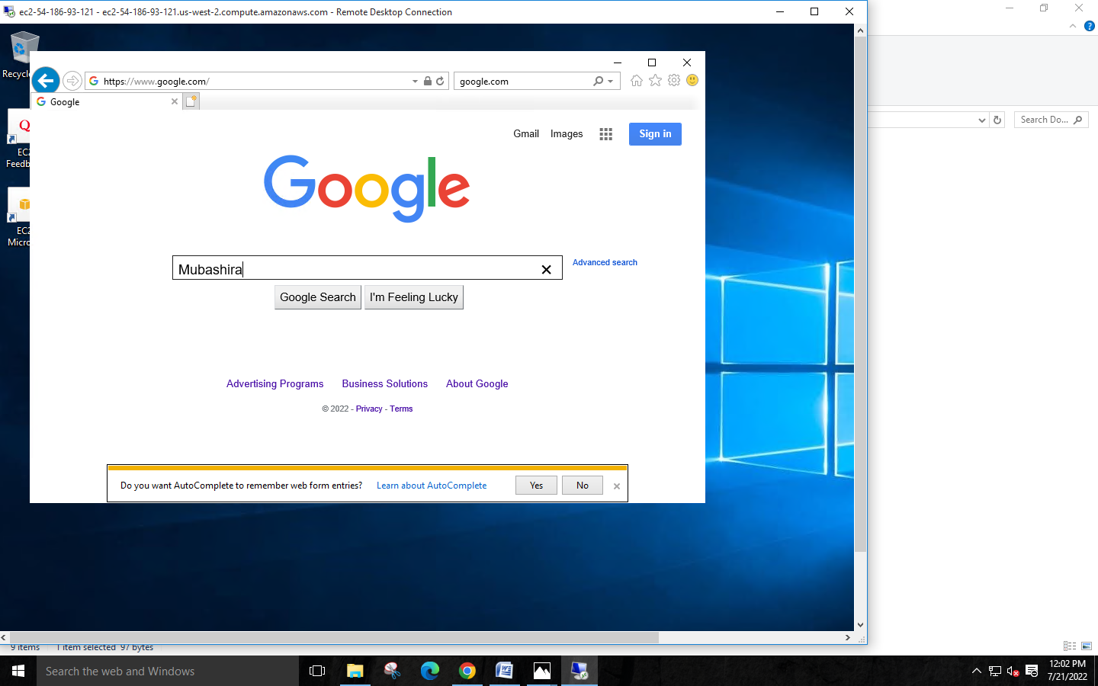

**(B)For Ubuntu:**

**Step 1: Select ubuntu**

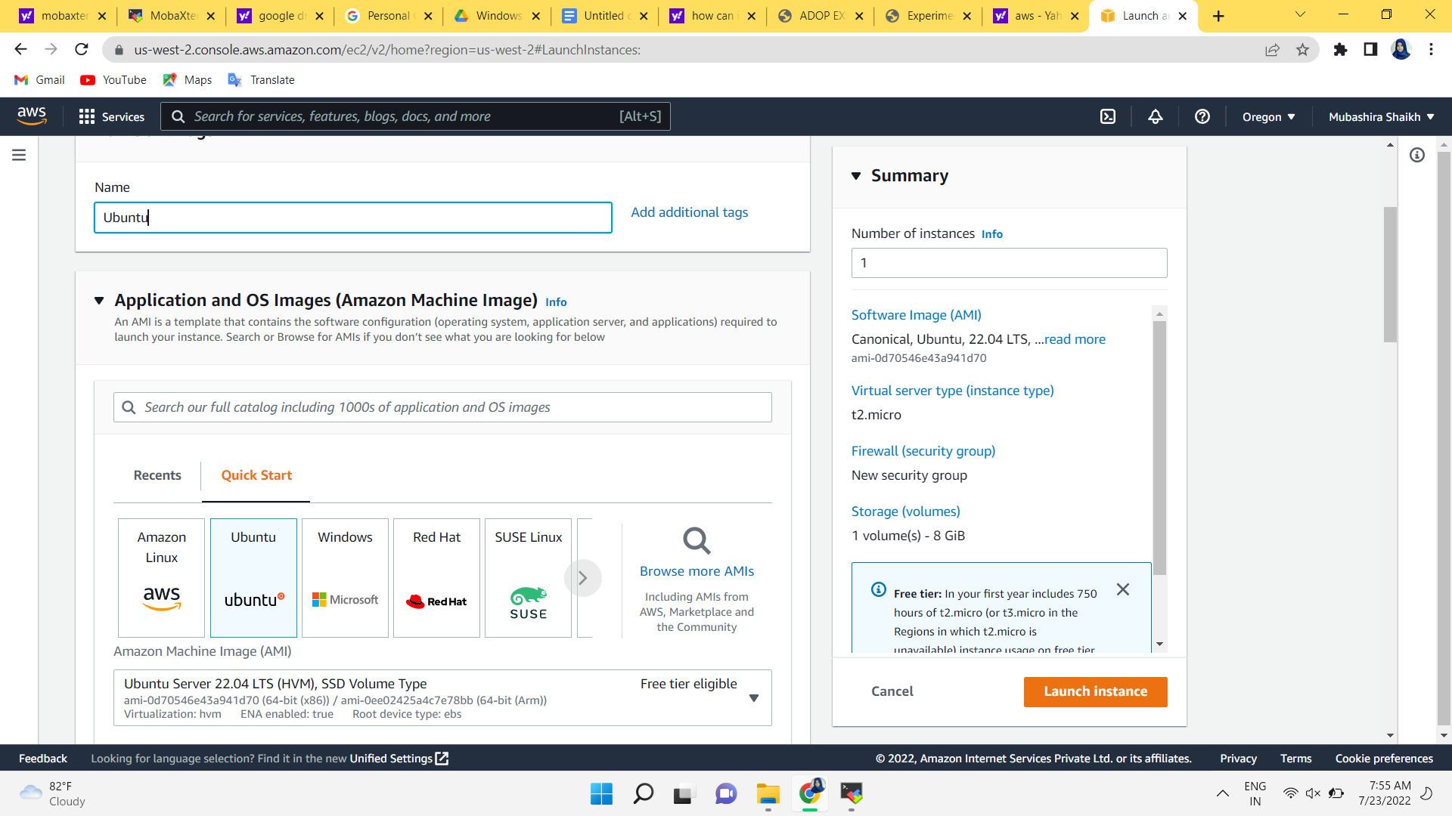

**Step 2: Login key**

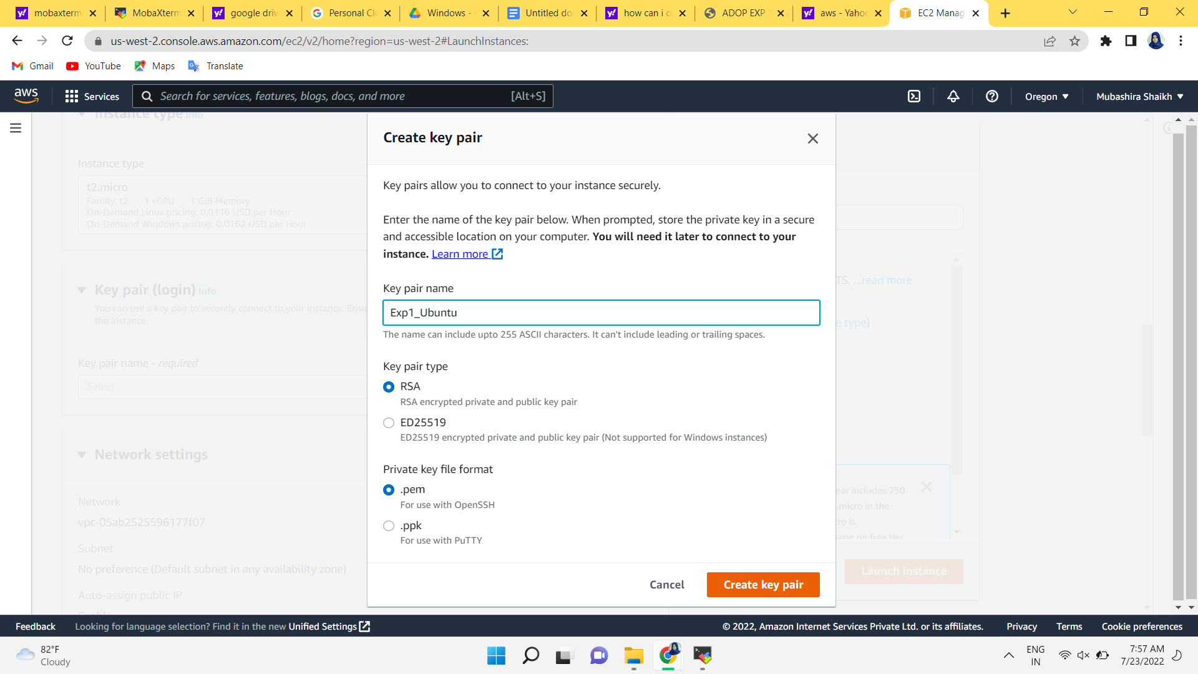

**Step 3: Launch Ubuntu instance**

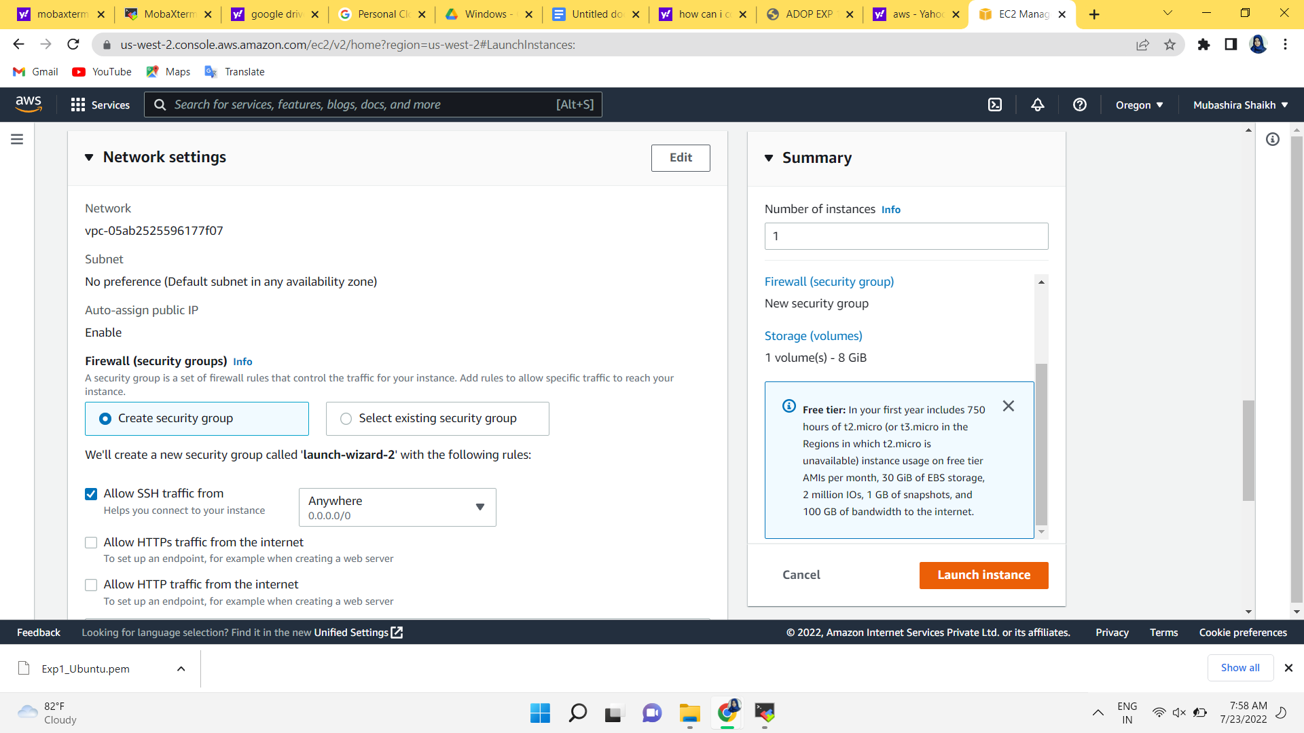

**\* Success msg will be shown after succucessfull creation of instance**

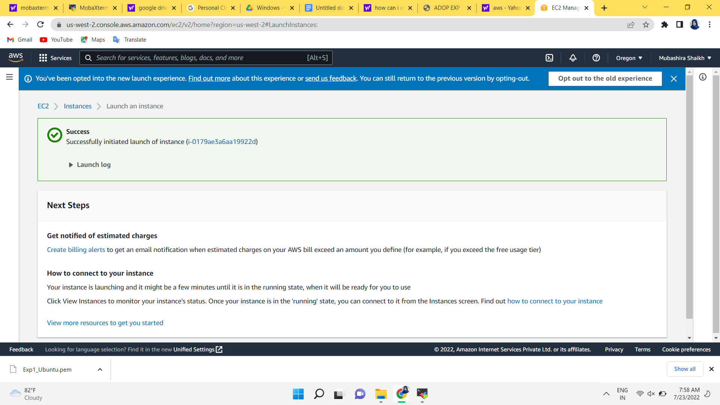

**Step 4: MobaXterm download**

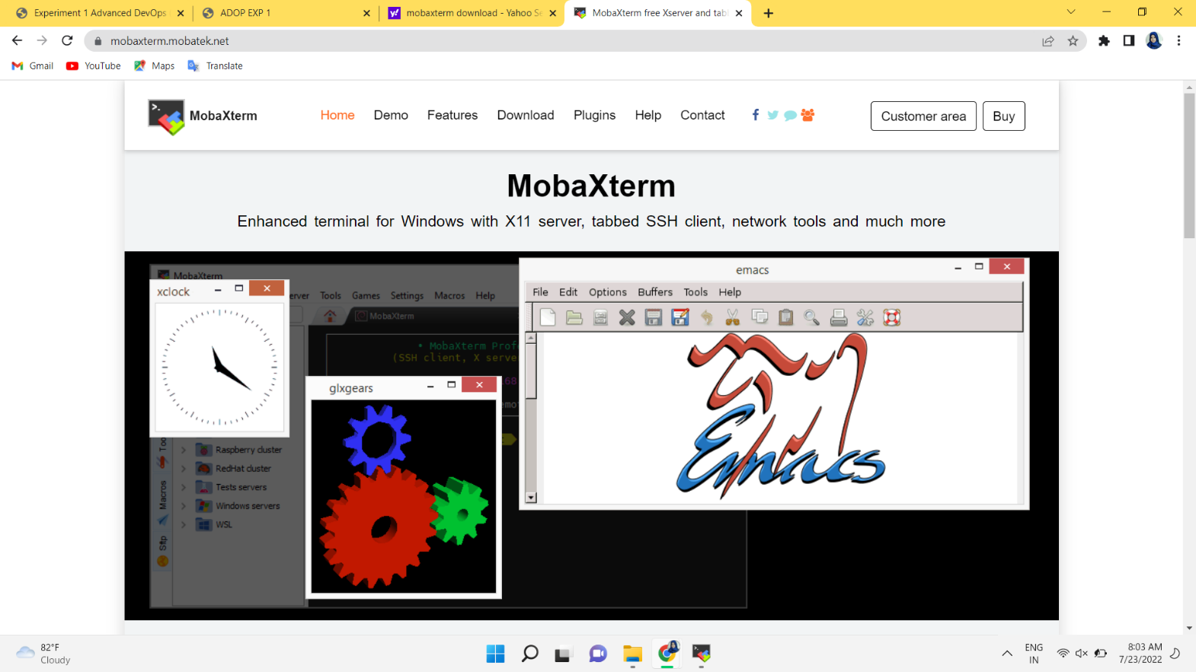

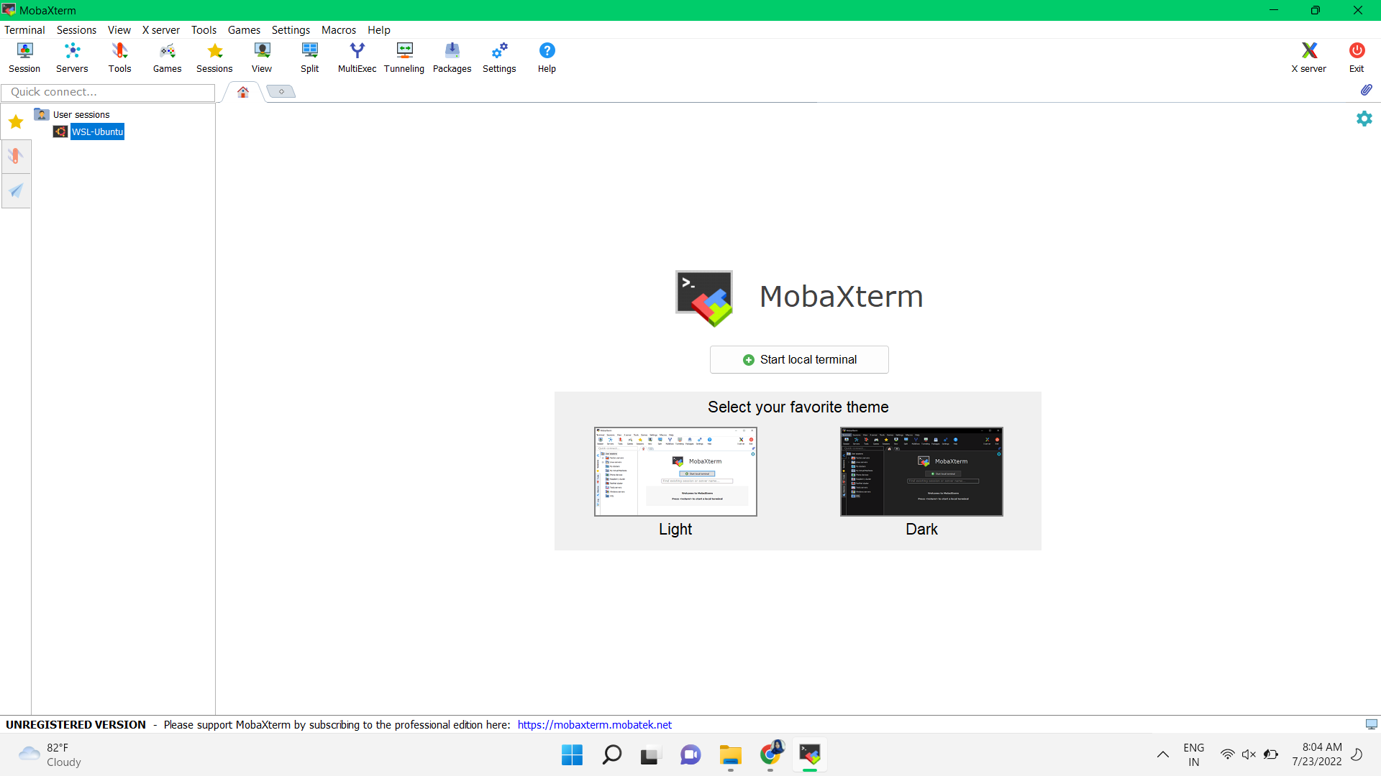

**Step 5: connection builduing with aws instance with mobaxterm ssh server**

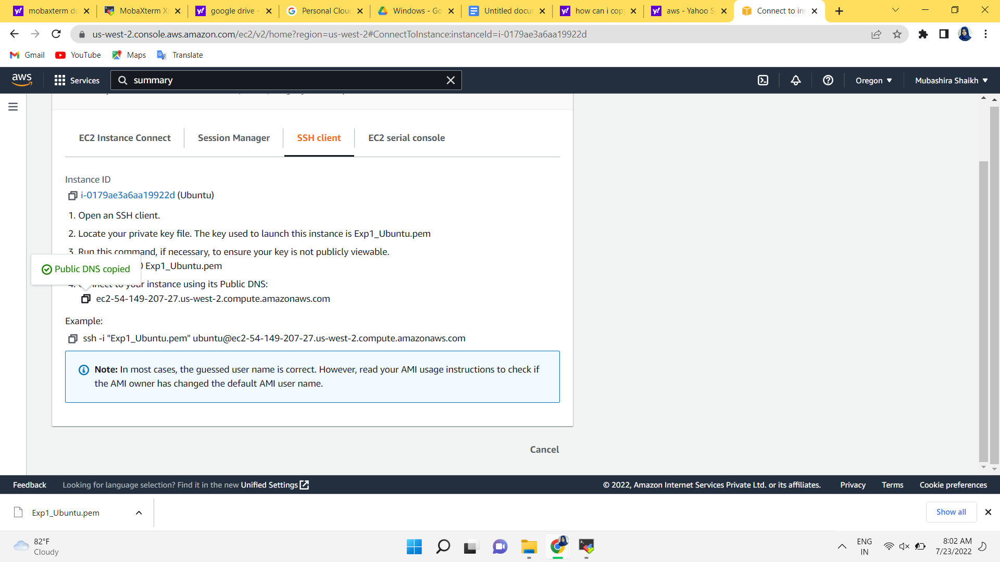

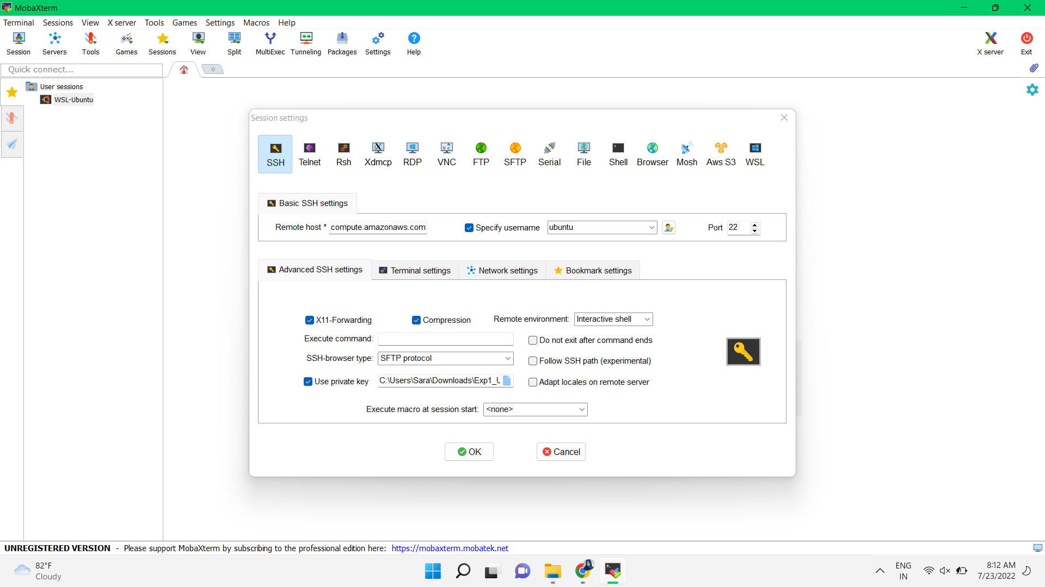

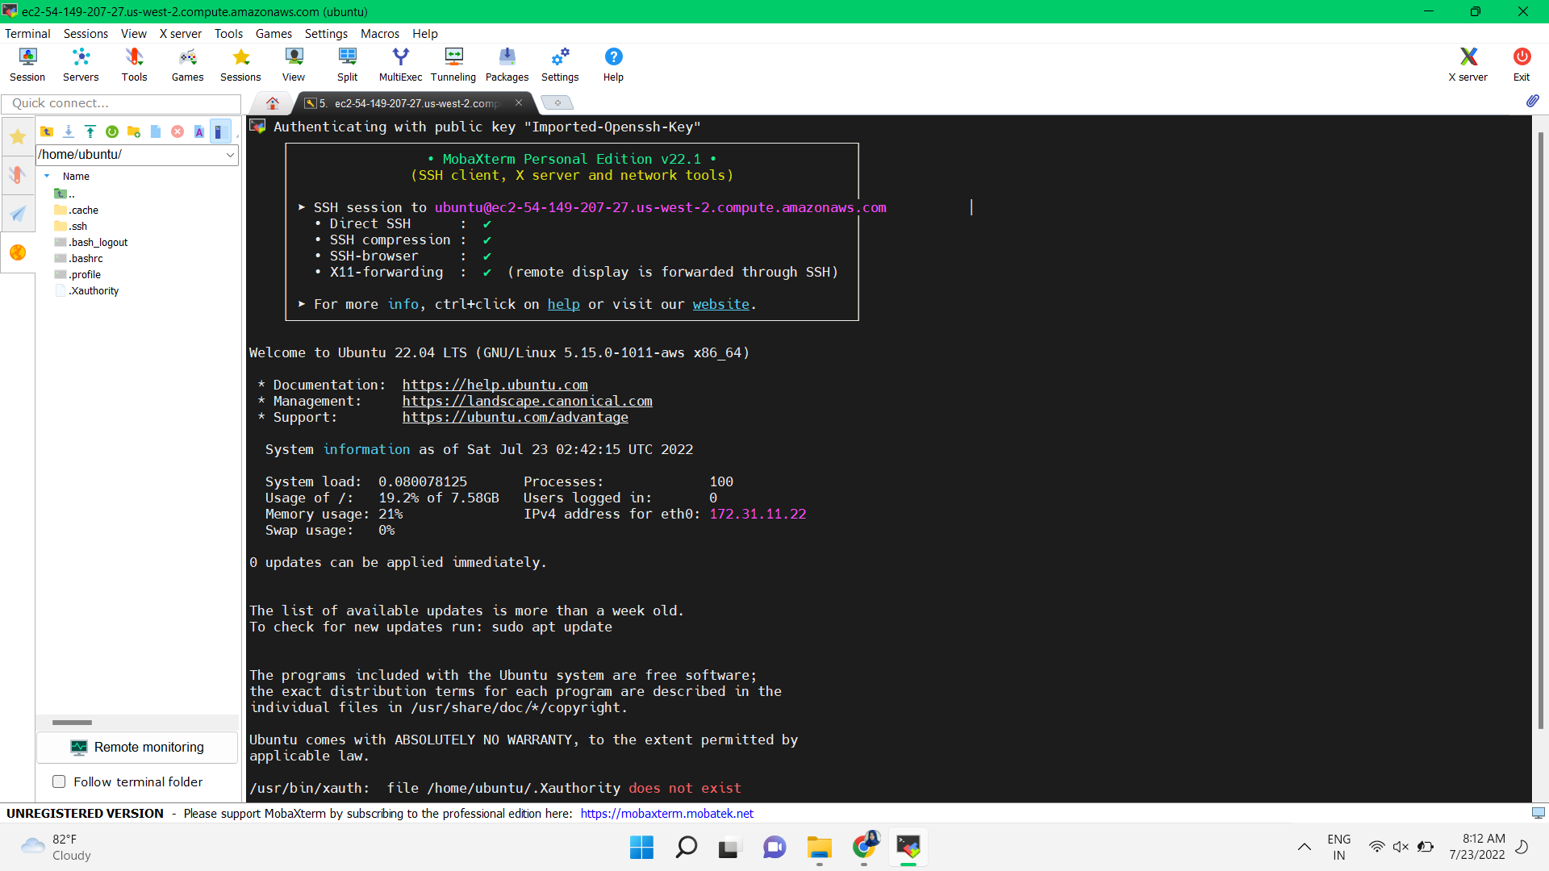

**Step 6 : writing some commands for execcuting google chrome through ubuntu server**

**Which are as follows**

**Sudo su**

**Sudo apt update**

**Sudo apt install wget**

**Create a directory**

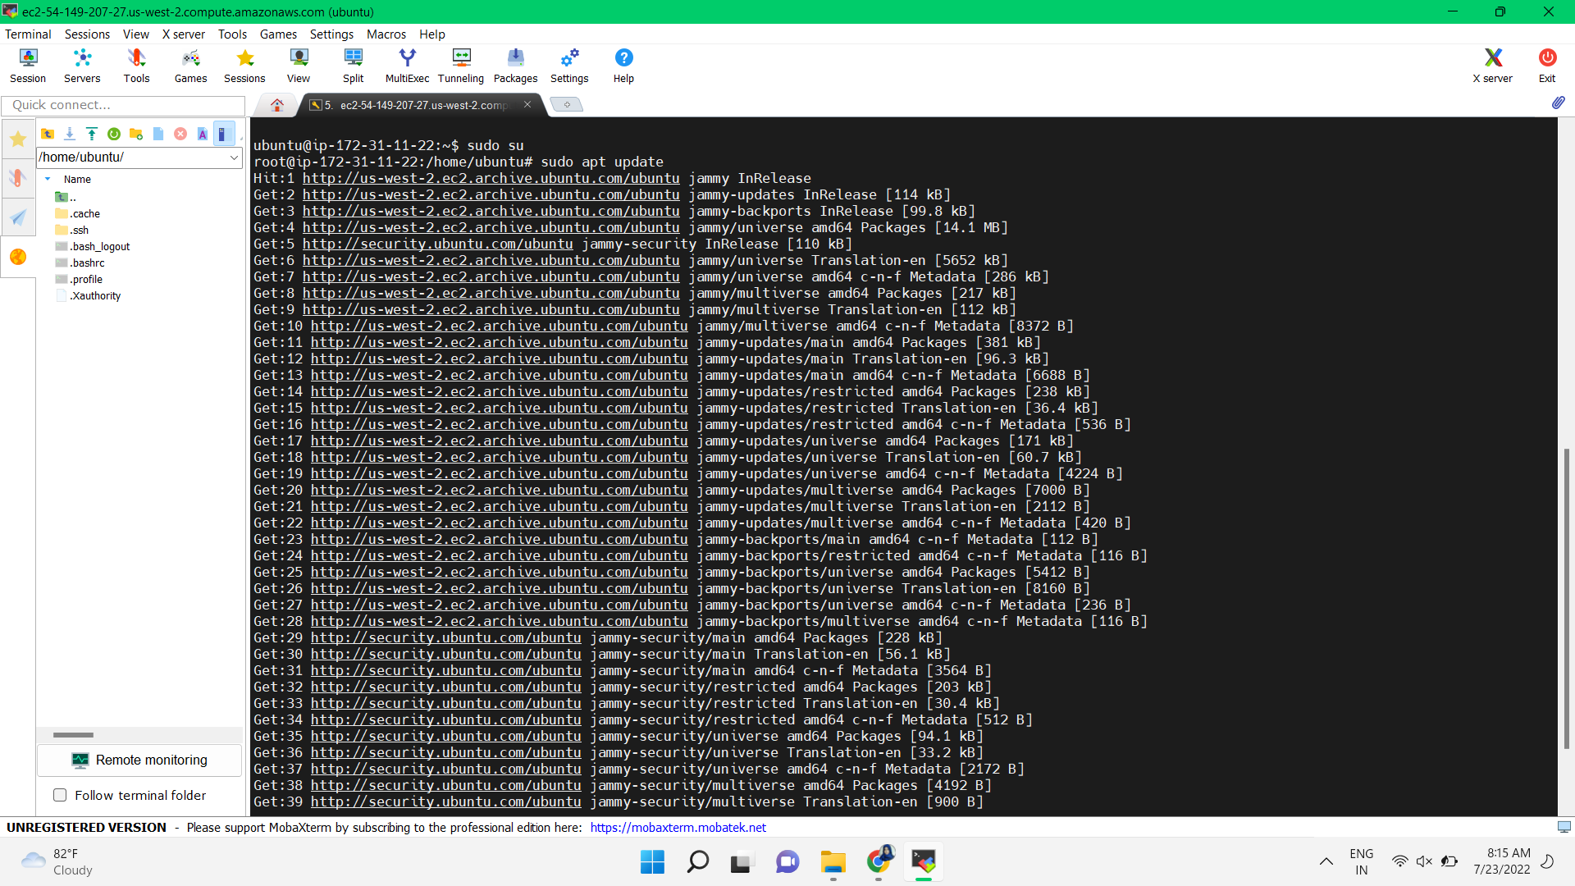

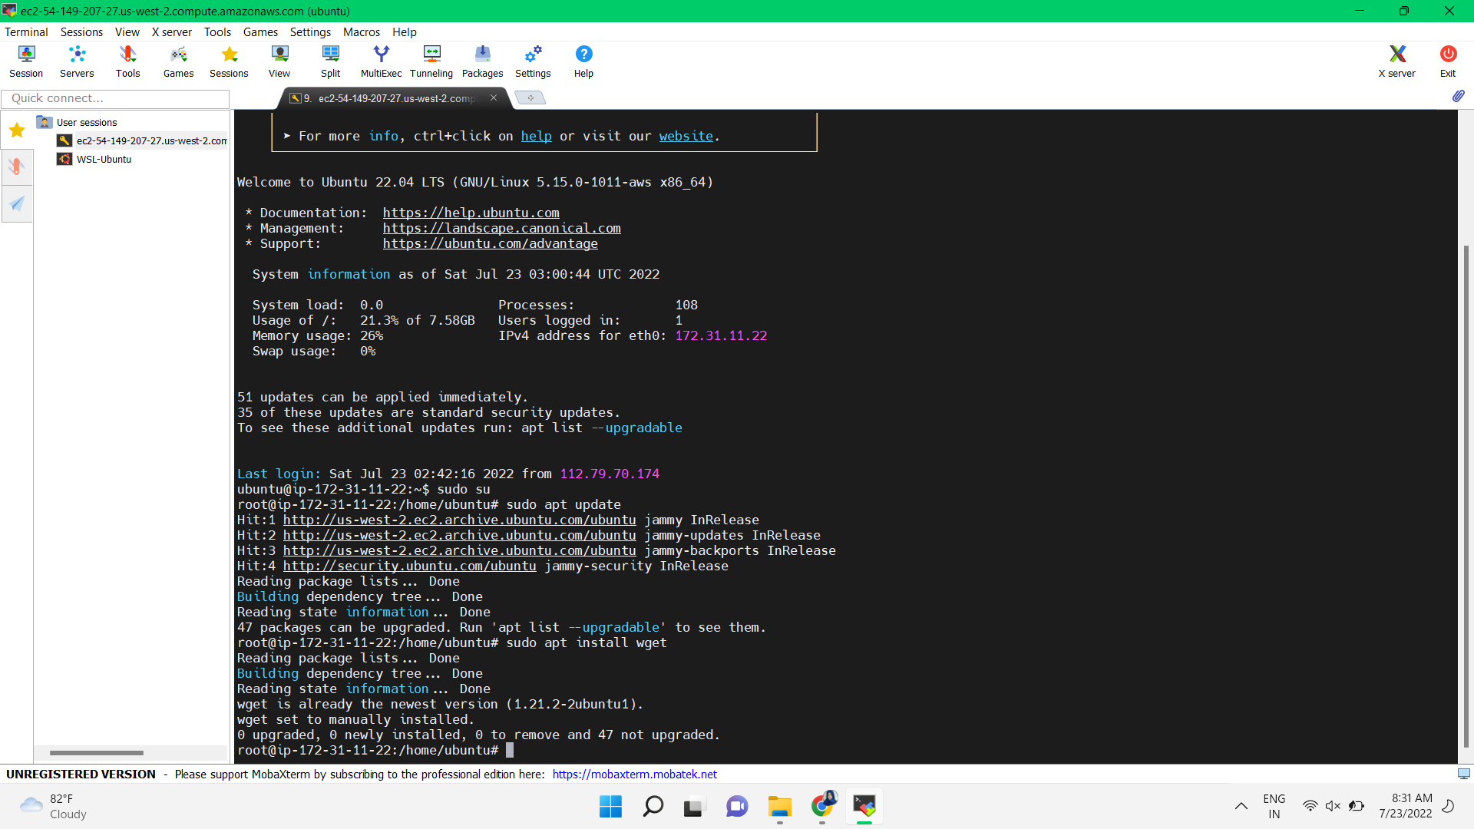

**Creating Directoty**

